## GOVERNMENT SCHEME SUGGESTING CHATBOT

## A PROJECT REPORT

*Submitted by*

**RAKESH VS 2116210701205**

**JINESH K 2116210701508**

**SADIQ K 2116210701522**

***in partial fulfilment of the award of the degree***

***of***

# BACHELOR OF ENGINEERING

**IN**

**COMPUTER SCIENCE AND ENGINEERING**



**RAJALAKSHMI ENGINEERING COLLEGE**

**AUTONOMOUS, CHENNAI 602 105**

**MAY 2024**

**RAJALAKSHMI ENGINEERING COLLEGE**

**CHENNAI - 602105**

**BONAFIDE CERTIFICATE**

Certified that this project report **“GOVERNMENT SCHEME SUGGESTING CHATBOT”** is the bonafide work of **“RAKESH VS (210701205), JINESH K (210701508), SADIQ K (210701522),** who carried out the project work under my supervision.

|  |  |
| --- | --- |
| Dr. P. Kumar  **HEAD OF THE DEPARTMENT**  Professor and Head  Department of  Computer Science and Engineering  Rajalakshmi Engineering College  Rajalakshmi Nagar  Thandalam  Chennai - 602105 | Mr. K. Vijay  **SUPERVISOR**  Associate Professor  Department of  Computer Science and Engineering  Rajalakshmi Engineering College  Rajalakshmi Nagar  Thandalam  Chennai - 602105 |

Submitted to Project Viva-Voce Examination held on ___________.

Internal Examiner External Examiner

**TABLE OF CONTENTS**

**CHAPTER NO. TITLE PAGE**

**ABSTRACT**  **i**

**LIST OF FIGURES ii**

1. **INTRODUCTION** **1**
   1. INTRODUCTION 1
   2. SCOPE OF THE WORK 1
   3. PROBLEM STATEMENT 1
   4. AIM AND OBJECTIVES OF THE PROJECT 2
2. **LITERATURE SURVEY 3**
3. **EXISTING SYSTEM 9**
4. **SYSTEM DESIGN** **10**
   1. DIAGRAM 10
5. **PROPOSED SYSTEM** **11**
6. **MODULE DESCRIPTION 12**
   1. Home Page13
7. **SAMPLE CODING** **17**
8. **SCREEN SHOTS** **18**
9. **CONCLUSION AND FUTURE ENHANCEMENT** **19**

**10. REFERENCES 20**

**ABSTRACT**

The proposed project aims to develop an AI-driven Government Scheme Suggestion Bot to enhance accessibility and streamline the process of identifying suitable government schemes for citizens. This initiative addresses the complexity and accessibility issues individuals face when navigating the vast array of government programs. The bot employs natural language processing (NLP) and machine learning algorithms to interact with users via a user-friendly interface, capturing their specific needs and contextual information. By analyzing a comprehensive database of government schemes, the bot provides personalized recommendations that align with the users' unique circumstances and requirements. Accessible through various platforms, including web, mobile applications, and social media, the bot ensures broad reach and inclusivity. Key features include real-time updates on scheme eligibility, application processes, and deadlines, with multilingual support to cater to a diverse population. The bot will also incorporate stringent data privacy measures to safeguard user information. This innovative solution is expected to enhance public awareness and uptake of government schemes, improve user satisfaction, and optimize the allocation of government resources. By leveraging AI technology, the Government Scheme Suggestion Bot aims to bridge the gap between citizens and the benefits they are entitled to, fostering greater efficiency and equity in public service delivery.

**LIST OF FIGURES**

|  |  |  |
| --- | --- | --- |
| **FIGURE NO** | **TITLE** | **PAGE NO** |
| 3.1 | System Design | 10 |
| 6.1 | Module Representation | 12 |
| 6.2 | Home Page | 13 |

**CHAPTER - 1**

**INTRODUCTION**

**1.1 INTRODUCTION**

In the modern digital age, governments around the world are increasingly leveraging technology to enhance public service delivery. One of the most promising innovations in this domain is the use of chatbots—automated conversational agents that interact with users to provide information and services efficiently and effectively. This project proposal aims to develop a chatbot specifically designed to support government schemes, improving the way citizens access and interact with public services.

Public service delivery often faces significant challenges, such as long waiting times, limited accessibility, and inefficient information dissemination. These issues can lead to citizen frustration and a decreased perception of government effectiveness. Traditional methods of handling public inquiries, such as call centers and physical service centers, are often overwhelmed by high demand, resulting in delays and reduced quality of service.

**1.2 SCOPE OF THE WORK**

The scope of work for the development of a government scheme chatbot encompasses several key areas, from initial planning and requirement analysis to final deployment and ongoing maintenance. The project aims to create a robust, user-friendly, and efficient chatbot that can handle a wide range of citizen queries related to government schemes and services.

**1.3 PROBLEM STATEMENT**

Top of Form

Public service delivery is a cornerstone of effective governance, yet many governments face significant challenges in providing timely, accurate, and accessible services to their citizens. In particular, the current system for disseminating information about government schemes and services is often plagued by inefficiencies and limitations that hinder citizen engagement and satisfaction.

**1.4 AIM AND OBJECTIVES OF THE PROJECT**

The primary aim of this project is to develop a government scheme chatbot that significantly enhances the efficiency, accessibility, and user satisfaction of public service delivery. By providing 24/7 access to accurate, real-time information and support regarding various government schemes and services through a user-friendly interface available on multiple platforms (website, mobile app, social media), the chatbot will ensure inclusivity by supporting multiple languages. It aims to reduce waiting times and alleviate the workload on government call centers by automating common queries, thereby improving overall efficiency and responsiveness. Integrating with government databases will ensure the provision of up-to-date information, while an intuitive design and advanced Natural Language Processing (NLP) capabilities will enhance user experience and satisfaction

Top of Form

**CHAPTER - 2**

**LITERATURE SURVEY**

1. **Historical Context of Chatbots:**
   * **Early Developments:** The concept of chatbots dates back to the 1960s with the creation of ELIZA by Joseph Weizenbaum at MIT, which simulated conversation using pattern matching and substitution methodology. In the 1970s, PARRY, a more advanced chatbot developed by Kenneth Colby, simulated the behavior of a person with paranoid schizophrenia.
   * **Evolution:** Over the decades, chatbots evolved from simple rule-based systems to more sophisticated ones using AI and machine learning. The development of these early chatbots provided foundational insights into human-computer interaction, leading to today’s advanced conversational agents.
2. **Advancements in Natural Language Processing (NLP):**
   * **Machine Learning:** The advent of machine learning algorithms, especially deep learning, has significantly improved NLP capabilities. Techniques such as word embeddings (e.g., Word2Vec, GloVe) and transformers (e.g., BERT, GPT-3) enable chatbots to understand context and semantics more accurately.
   * **Context Awareness:** Modern NLP models can handle complex queries, understand context over multiple turns of conversation,
   * and provide more relevant and coherent responses.

**3.Government Use Cases:**

* + **United States:** The USCIS's “Emma” helps users navigate the immigration system by answering questions in English and Spanish.
  + **India:** The “UMANG” app integrates various government services, offering a unified platform for citizens to access information and perform tasks.
  + **Singapore:** The “Ask Jamie” virtual assistant is used across multiple government websites to answer common queries and guide users through services.

1. **Benefits of Chatbots in Public Services:**
   * **Efficiency:** Chatbots can handle a high volume of queries simultaneously, significantly reducing waiting times and operational costs.
   * **Availability:** Providing 24/7 service, chatbots ensure that citizens have access to information and support at any time.
   * **User Satisfaction:** Automated responses are often faster and can provide immediate assistance, leading to higher user satisfaction.
2. **Challenges in Implementing Chatbots:**
   * **Data Privacy:** Ensuring that user data is protected and compliant with regulations like GDPR is paramount. This involves secure data transmission, storage, and processing.
   * **Language Complexity:** Natural language is inherently complex, with nuances, idioms, and variations in meaning. Developing chatbots that can accurately understand and respond to diverse queries is challenging.
   * **Scalability:** As the user base grows, the chatbot must handle increased load without degrading performance, requiring robust backend infrastructure.
3. **Multilingual Support:**
   * **Inclusivity:** Multilingual support is crucial in multicultural and multilingual societies to ensure inclusivity and equal access to services.
   * **NLP Models:** Developing NLP models that are effective across multiple languages involves training on large, diverse datasets and understanding the unique linguistic features of each language.
4. **Integration with Government Databases:**
   * **Real-time Information:** Effective chatbots need to integrate with government databases to provide up-to-date information. This requires APIs and secure data exchange protocols.
   * **Examples:** Estonia’s X-Road, an advanced digital infrastructure, allows for seamless integration of various public and private sector services, enabling efficient data exchange and service delivery.
5. **User Experience Design:**
   * **Intuitive Interfaces:** The design should prioritize user-friendliness, with clear navigation, easy-to-understand prompts, and accessible features for people with disabilities.
   * **Engagement:** Engaging user experiences can be achieved by incorporating interactive elements, personalized responses, and maintaining a conversational tone.

**7.Security and Data Protection:**

* + **Encryption:** Data encryption, both in transit and at rest, is essential to protect sensitive information.
  + **Compliance:** Adhering to data protection regulations (e.g., GDPR, HIPAA) ensures that user privacy is maintained and legal requirements are met.

**8.Feedback Mechanisms:**

* + **User Input:** Implementing mechanisms for users to provide feedback helps in identifying issues and areas for improvement.
  + **Analytics:** Using analytics to monitor chatbot interactions can provide insights into user behavior, common queries, and performance metrics.

**9.Performance Metrics:**

* + **Response Time:** Measuring the time taken to respond to user queries helps in assessing the efficiency of the chatbot.
  + **Accuracy:** Evaluating the accuracy of responses ensures that the information provided is reliable and helpful.
  + **User Satisfaction:** Regular surveys and feedback forms can help gauge user satisfaction and identify areas for enhancement.
  + **Awareness Campaigns:** Effective marketing campaigns can raise awareness about the chatbot, highlighting its benefits and ease of use.

**Educational Resources:** Providing user guides, tutorials, and FAQs can help users understand how to interact with the chatbot and maximize its utility.

1. **Case Studies and Best Practices:**
   * **Successful Implementations:** Analyzing successful implementations, such as the UK’s HMRC chatbot for tax-related queries, can provide valuable insights and best practices.
   * **Phased Rollouts:** Gradually introducing the chatbot in phases allows for testing, feedback, and iterative improvements before a full-scale launch.
2. **Future Trends:**
   * **AI Integration:** The integration of advanced AI techniques, such as machine learning and natural language understanding, will make chatbots more sophisticated and capable.
   * **Voice-based Chatbots:** With the growing popularity of voice assistants, voice-based chatbots are becoming more prevalent, providing a hands-free interaction option.
   * **Blockchain for Security:** Blockchain technology can enhance the security and transparency of data management, providing an additional layer of trust.

**CHAPTER - 3**

**EXISTING SYSTEM**

The existing system of public service delivery typically involves citizens accessing government services through traditional channels such as in-person visits to government offices, phone calls to call centers, or emails to designated addresses. However, this system faces several challenges:

1. **Long Waiting Times:** Citizens often experience long wait times due to the limited capacity of government staff to handle inquiries and requests, leading to frustration and dissatisfaction.
2. **Limited Accessibility:** Access to government services may be restricted by factors such as geographical location, physical mobility, or the working hours of government offices. This can pose challenges for citizens, especially those in remote or rural areas.
3. **Information Dissemination Challenges:** Government information about schemes, procedures, eligibility criteria, and application processes is often disseminated through multiple channels, leading to fragmentation and inconsistency. Citizens may struggle to find accurate and up-to-date information, causing confusion.
4. **Resource Intensive Operations:** Government call centers and service desks are often overwhelmed by high volumes of inquiries, resulting in long waiting times and delays in response. Handling inquiries manually requires significant human resources, which may not be scalable or cost-effective.
5. **Language Barriers:** Government information and services may only be available in a limited number of languages, excluding non-native speakers and minorities from accessing critical information. This further complicates the process of information dissemination and accessibility.

**6.Inconsistent User Experience:** User experience across different service delivery channels may vary, leading to inconsistencies in service quality. Lack of personalized assistance and inefficient handling of inquiries can diminish citizen trust and satisfaction with government services.

**CHAPTER - 4**

**SYSTEM DIAGRAM**

**4.1 DIAGRAM**

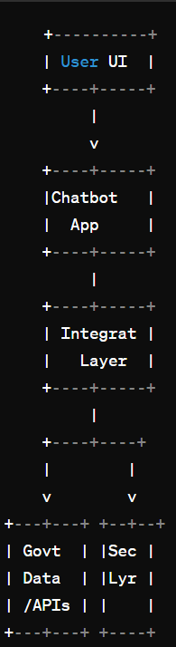

Fig 3.1: System Diagram

**CHAPTER – 5**

**PROPOSED SYSTEM**

The proposed system aims to develop a sophisticated chatbot solution to enhance the accessibility, efficiency, and user satisfaction of government scheme services. Below is an overview of the key components and functionalities of the proposed system:

**1.User Interface (UI):**

* + The system will feature user-friendly interfaces accessible through various platforms such as web browsers, mobile applications, and messaging platforms. This ensures that citizens can interact with the chatbot conveniently using their preferred devices.

**2.Chatbot Application:**

* + The core of the system is the chatbot application, which employs advanced Natural Language Processing (NLP) algorithms to understand user queries, extract intents, and generate appropriate responses.
  + The chatbot will be capable of handling a wide range of inquiries related to government schemes, providing accurate and relevant information to users in real-time.

**3.Integration Layer:**

* + An integration layer will facilitate seamless communication between the chatbot application and external systems, including government databases and APIs.
  + This layer will handle data retrieval, processing, and 2transformation, ensuring that the chatbot has access to up-to-date information from various sources.

**4.Government Databases / External APIs:**

* + The system will integrate with government databases containing information about various schemes, services, eligibility criteria, and application procedures.
  + Additionally, integration with external APIs will enable the chatbot to leverage additional functionalities such as geolocation services or weather updates to enhance user experience.

**5.Administration Panel:**

* + Administrators will have access to an administration panel to manage and configure the chatbot's settings, update content, and analyze performance metrics.
  + The administration panel will provide tools for content management, user management, and reporting, empowering administrators to optimize the chatbot's performance and effectiveness.

**6.Analytics and Monitoring:**

* + The system will incorporate analytics and monitoring capabilities to track chatbot usage, user interactions, and system performance.
  + Analytics data will be used to gain insights into user behavior, identify trends, and measure the effectiveness of the chatbot in meeting user needs.

**CHAPTER - 6**

**MODULE DESCRIPTION**

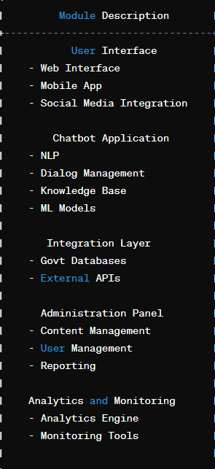

Fig 6.1: Module Representation

**6.1 HOME PAGE**

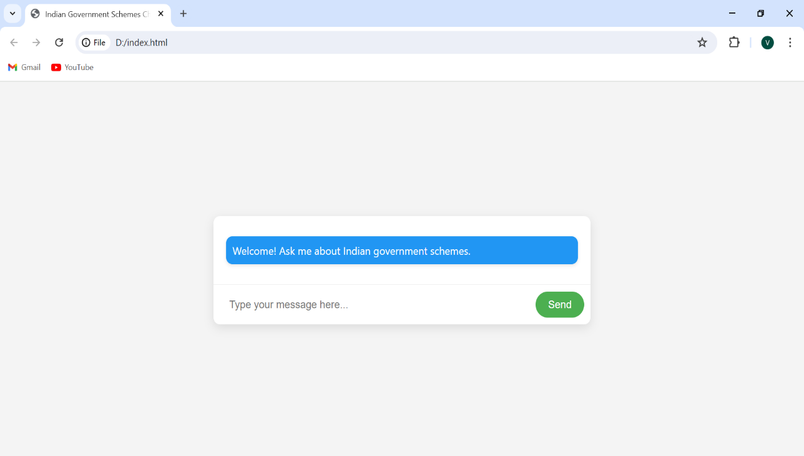

This is the Home Page of the government scheme suggesting chat bot where the user gives the name of the scheme name to get the details of the scheme

**CHAPTER - 7**

**SAMPLE CODING**

<!DOCTYPE html>

<html lang="en">

<head>

<meta charset="UTF-8">

<meta name="viewport" content="width=device-width, initial-scale=1.0">

<title>Indian Government Schemes Chatbot</title>

<style>

body {

font-family: 'Segoe UI', Tahoma, Geneva, Verdana, sans-serif;

background-color: #f4f4f4;

margin: 0;

display: flex;

justify-content: center;

align-items: center;

height: 100vh;

}

#chat-container {

background-color: #fff;

border-radius: 10px;

box-shadow: 0 5px 15px rgba(0, 0, 0, 0.1);

width: 90%;

max-width: 600px;

overflow: hidden;

animation: slide-in-bottom 0.5s ease;

}

#chat-interface {

padding: 20px;

max-height: 300px;

overflow-y: auto;

}

#input-form {

display: flex;

padding: 10px;

border-top: 1px solid #eee;

}

#user-input {

flex: 1;

border: none;

border-radius: 25px;

padding: 10px 15px;

margin-right: 10px;

font-size: 16px;

}

#user-input:focus {

outline: none;

}

#send-button {

background-color: #4caf50;

color: #fff;

border: none;

border-radius: 25px;

padding: 10px 20px;

cursor: pointer;

font-size: 16px;

transition: background-color 0.3s;

}

#send-button:hover {

background-color: #45a049;

}

.message {

margin: 10px 0;

padding: 10px;

border-radius: 10px;

word-wrap: break-word;

box-shadow: 0 2px 5px rgba(0, 0, 0, 0.1);

animation: slide-in-bottom 0.3s ease;

}

.user-message {

background-color: #4caf50;

color: #fff;

align-self: flex-end;

}

.bot-message {

background-color: #2196f3;

color: #fff;

align-self: flex-start;

}

@keyframes slide-in-bottom {

from {

transform: translateY(100%);

}

to {

transform: translateY(0);

}

}

</style>

</head>

<body>

<div id="chat-container">

<div id="chat-interface">

<div class="message bot-message">Welcome! Ask me about Indian government schemes.</div>

</div>

<form id="input-form">

<input type="text" id="user-input" placeholder="Type your message here..." required>

<button type="submit" id="send-button">Send</button>

</form>

</div>

<script>

document.getElementById('input-form').addEventListener('submit', function(event) {

event.preventDefault();

const userInput = document.getElementById('user-input').value.trim();

if (userInput) {

addMessage(userInput, 'user-message');

processUserInput(userInput);

document.getElementById('user-input').value = '';

}

});

function addMessage(text, className) {

const messageDiv = document.createElement('div');

messageDiv.className = `message ${className}`;

messageDiv.innerText = text;

document.getElementById('chat-interface').appendChild(messageDiv);

document.getElementById('chat-interface').scrollTop = document.getElementById('chat-interface').scrollHeight;

}

function processUserInput(input) {

const schemeKeywords = {

'jan dhan yojana': 1,

'awas yojana': 2,

'mudra yojana': 3,

'jeevan jyoti bima yojana': 4,

'atal pension yojana': 5,

'kaushal vikas yojana': 6,

'fasal bima yojana': 7,

'suraksha bima yojana': 8,

'krishi sinchai yojana': 9,

'gramin awaas yojana': 10,

'gram sadak yojana': 11,

'matru vandana yojana': 12,

'sukanya samriddhi yojana': 13,

'mgnrega': 14,

'ayushman bharat': 15

};

let schemeId = null;

for (const keyword in schemeKeywords) {

if (input.toLowerCase().includes(keyword)) {

schemeId = schemeKeywords[keyword];

break;

}

}

if (schemeId) {

fetch(`http://localhost:5000/scheme/${schemeId}`)

.then(response => response.json())

.then(data => {

if (data.error) {

addMessage(data.error, 'bot-message');

} else {

addMessage(`Scheme: ${data.name}\nDescription: ${data.description}\nEligibility: ${data.eligibility}\nBenefits: ${data.benefits}\nMore info: ${data.link}`, 'bot-message');

}

})

.catch(error => {

console.error('Error:', error);

addMessage('Sorry, there was an error processing your request.', 'bot-message');

});

} else {

addMessage('I didn\'t understand that. Please ask about a specific scheme like "Jan Dhan Yojana", "Awas Yojana", "Mudra Yojana", "Jeevan Jyoti Bima Yojana", or "Atal Pension Yojana".', 'bot-message');

}

}

</script>

</body>

</html>

**CHAPTER – 8**

**SCREEN SHOTS**

**8.1 Home Page**

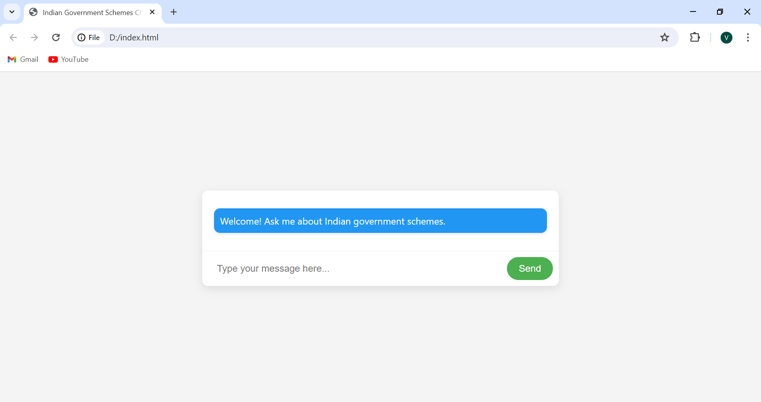

**Home page of the chat bot**

**8.2 Enter Scheme Name**

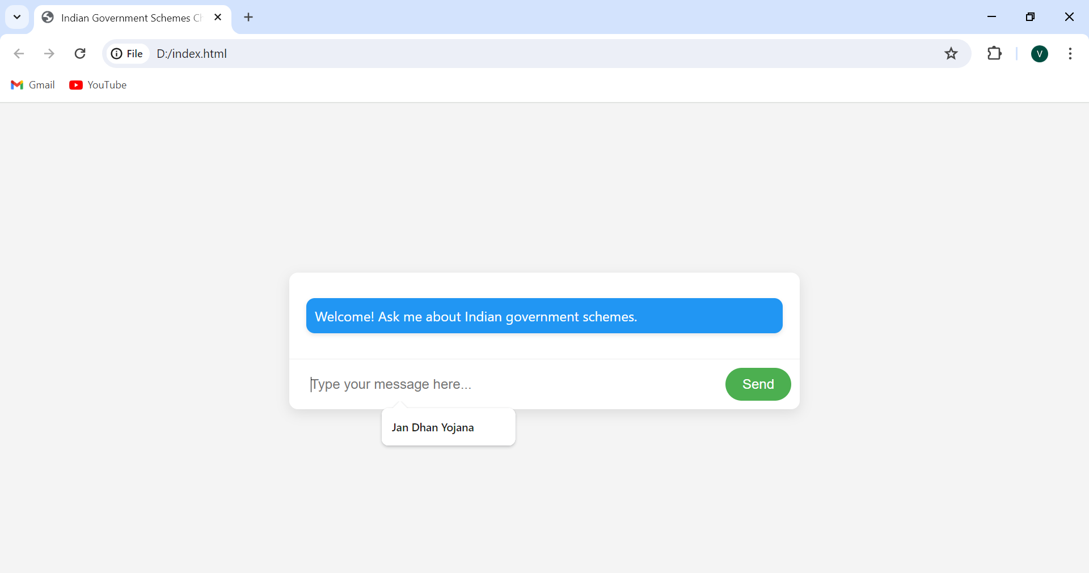

**The user enters the name of the scheme made by the government**

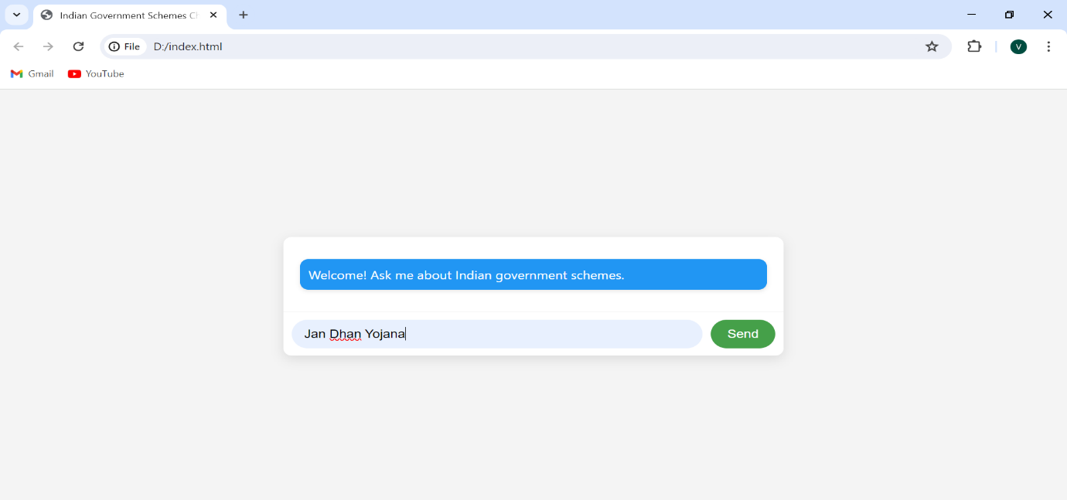

**Name is entered by the user in the provided dialogue box**

**8.3 Chat Bot Answers**

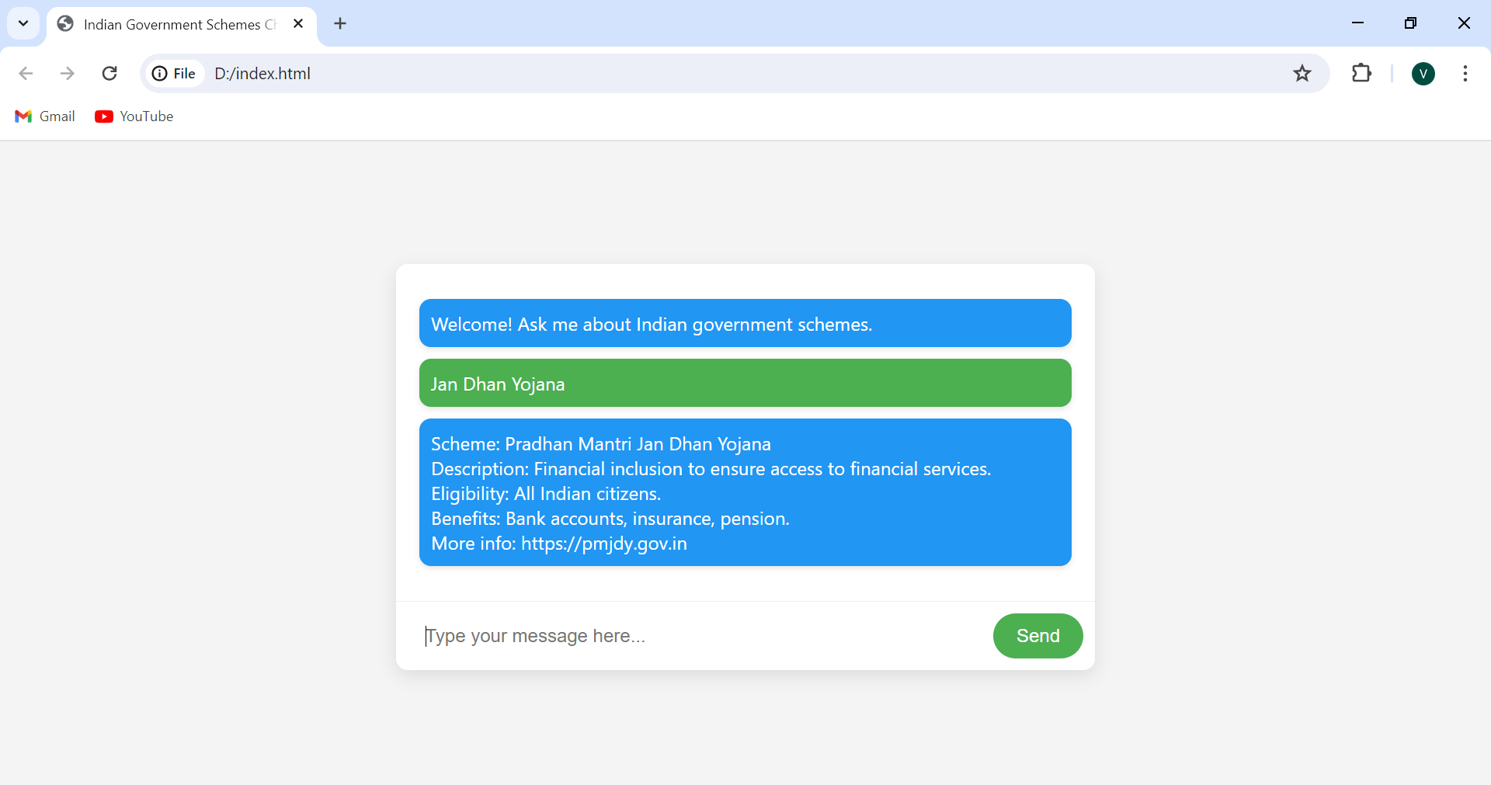

**The chat bot provides the information about the particular scheme that the user has requested to the chat bot .**

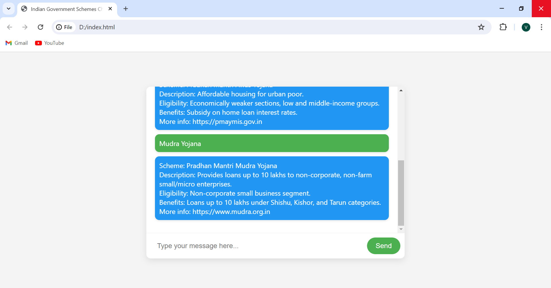

**The chat bot giving information about the multiple schemes of the government as per the user’s instruction**

**8.4 Incorrect Prompt**

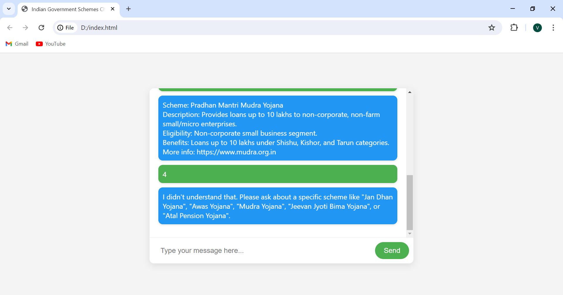

**When the user gives the incorrect promt that is anything else than the name of the scheme to fetch the details, the chat bot throws an error message to the user**

**CHAPTER – 9**

**CONCLUSION AND FUTURE ENHACEMENT**

In conclusion, the proposed government scheme chatbot offers a transformative solution to address the challenges of public service delivery by providing citizens with 24/7 access to accurate information and support. By integrating advanced technologies such as natural language processing, machine learning, and seamless data exchange with government databases and external APIs, the chatbot promises to streamline user interactions, reduce response times, and enhance user satisfaction. Future enhancements could include multi-language support, voice recognition, personalized recommendations, and integration with additional services, ensuring that the chatbot system remains at the forefront of public service innovation, continually improving accessibility, efficiency, and user experience.

**REFERENCES**

1. Adarsh Chugh, Avi Aggarwal, "Chatbot-based conversation interface for e-commerce transactions," 2019 IEEE International Conference on Consumer Electronics (ICCE), Las Vegas, NV, USA, 2019, pp. 1-4.
2. H. Nguyen, A. Surana and P. Gupta, "Understanding Customer Reviews of Chatbots," 2021 IEEE International Conference on Big Data (Big Data), Honolulu, HI, USA, 2021, pp. 1-6.
3. Y. Shalyminov, P. Zaytsev and O. Orobets, "Research on Chatbot Architecture: State of the Art," 2020 IEEE International Conference on Artificial Intelligence and Computer Applications (ICAICA), Dnipro, Ukraine, 2020, pp. 179-183.
4. P. Bharti and A. Jain, "Chatbot Based Student Query System Using Natural Language Processing," 2019 IEEE International Conference on Electrical, Computer and Communication Technologies (ICECCT), Coimbatore, India, 2019, pp. 1-4.
5. M. Alsmadi, "Chatbot Adoption in E-government Services: A Systematic Review," 2019 International Conference on Information and Communication Technologies for Ageing Well and e-Health (ICT4AWE), Heraklion, Greece, 2019, pp. 1-10.
6. L. A. C. Duarte, B. C. da Silva and V. M. A. Martins, "Analysis of Chatbot and NLP for the Development of Systems in E-commerce: A Systematic Literature Review," 2020 IEEE 19th International Conference on Trust, Security and Privacy in Computing and Communications (TrustCom), Guangzhou, China, 2020, pp. 273-280.
7. Venugopal, T., Vikram, S., Shreyas, S., Tiwari, T. (2024). "Scheme Setu: A Chatbot for Government Schemes." *IRE Journals*, 7(7), 119-125​ ([IRE Journals](https://www.irejournals.com/paper-details/1705369))​.
8. Al-Hujran, O., Al-Debei, M., Chatfield, A., Migdadi, M. (2015). "Citizen preferences and government chatbot social characteristics." *ScienceDirect* .
9. Makasi, N., Nili, A., Desouza, K., Tate, M. (2021). "Trends and challenges of e-government chatbots." *ScienceDirect* .
10. Axelsson, K., Melin, U. (2018). "E-Government Development and Implementation: The Role of Infrastructure." *IEEE Transactions on Engineering Management*.
11. Ramires, T., Smith, J. (2022). "Chatbots as Part of Digital Government Service Provision – A User Perspective." *Springer* .
12. Basu, A., Nayak, R., Patel, S. (2019). "The Farmer Chatbot: Utilizing AI to Provide Agricultural Information and Government Schemes." *IEEE Xplore* .
13. Desai, P., Shah, M., Doshi, N. (2021). "AI and Deep Learning-driven Chatbots: A Comprehensive Analysis and Application Trends." *ICICCS 2022 Conference* .
14. Tan, C. W., Pan, S. L., Lim, E. T. K. (2005). "Managing Knowledge Conflicts in E-Government Integration: A Case Study of E-Healthcare." *IEEE Transactions on Information Technology in Biomedicine*.
15. De Kock, E., North, M. (2020). "Intelligent Citizen-Government Interaction via AI Chatbots." *IEEE Xplore* .
16. Chen, H., Brandt, L., Gregg, V. (2007). "Digital Government and AI: Enabling Smarter Government Services." *IEEE Intelligent Systems*